# Task description.

Просьба создать input-ы в graylog:
для сбора данных от collector sidecar:
fintech-app-test
fintech-app-prod
для для сбора данных от syslog:
front-nginx-test
front-nginx-prod

и предоставить доступ к этим данным всем участником группы devops, а также следующим пользователям:
Akol'zin Aleksandr <a.akolzin@tinkoff.ru>;
Loginov Anton Petrovich <a.loginov@tinkoff.ru>;
Goloshchapova Aleksandra Sergeevna <a.goloshchapova@tinkoff.ru>;
Shestimerova Ekaterina Konstantinovna <e.k.shestimerova@tinkoff.ru>;
Grishkin Maksim Sergeevich <m.grishkin@tinkoff.ru>

--
Best regards,
Mikhail Efremov
Tinkoff Bank
Tel: +7495 648 1000 #2350
Mobile: +7903 223 8162
E-mail: m.efremov@tinkoff.ru

................................................................................

[root@ds-graylog-lb01 ~]# ls -1 /etc/keepalived/conf.d/ | sort -t "-" -k 2 -n
tcp-443-input.conf
udp-8702-input.conf
udp-12200-input.conf
udp-12201-input.conf
tcp-12300-input.conf
tcp-12301-input.conf
tcp-12302-input.conf
udp-12310-input.conf
tcp-12311-input.conf
udp-12311-input.conf
...
udp-12413-input.conf
udp-12414-input.conf
udp-12415-input.conf
udp-12416-input.conf
tcp-12900-input.conf
[root@ds-graylog-lb01 ~]#

[root@ds-graylog-lb01 ~]# cp /etc/keepalived/conf.d/udp-1241{6,7}-input.conf

# Changing in new file all port number “12416” to new one “12417”.

[root@ds-graylog-lb01 ~]# /etc/init.d/keepalived restart
Stopping keepalived: [ OK ]
Starting keepalived: [ OK ]
[root@ds-graylog-lb01 ~]# ipvsadm -L -n | grep 12417
UDP 10.216.40.170:12417 rr
-> 10.217.26.3:12417 Masq 1 0 0
-> 10.217.26.4:12417 Masq 1 0 0
[root@ds-graylog-lb01 ~]#

[root@ds-graylog-lb01 ~]# scp /etc/keepalived/conf.d/udp-12417-input.conf m1-graylog-lb01:/etc/keepalived/conf.d/
udp-12417-input.conf 100% 610 0.6KB/s 00:00
[root@ds-graylog-lb01 ~]#

[root@ds-graylog-lb01 ~]# ssh m1-graylog-lb01
Last login: Wed Oct 21 14:45:15 2015 from toi0013.ti.local
[root@m1-graylog-lb01 ~]# /etc/init.d/keepalived restart
Stopping keepalived: [ OK ]
Starting keepalived: [ OK ]
[root@m1-graylog-lb01 ~]# ipvsadm -L -n | grep 12417
UDP 10.216.40.170:12417 rr
-> 10.217.26.3:12417 Masq 1 0 0
-> 10.217.26.4:12417 Masq 1 0 0
[root@m1-graylog-lb01 ~]#

# After this, continue configuring with web GUI.
https://ha-graylog.tcsbank.ru/system/inputs

gl2_source_input:58a411d232f0673c834bbb47

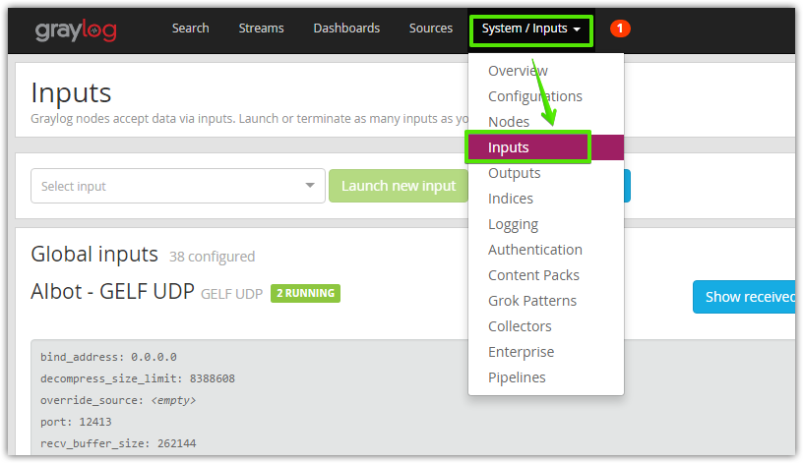

# “Launch new input”
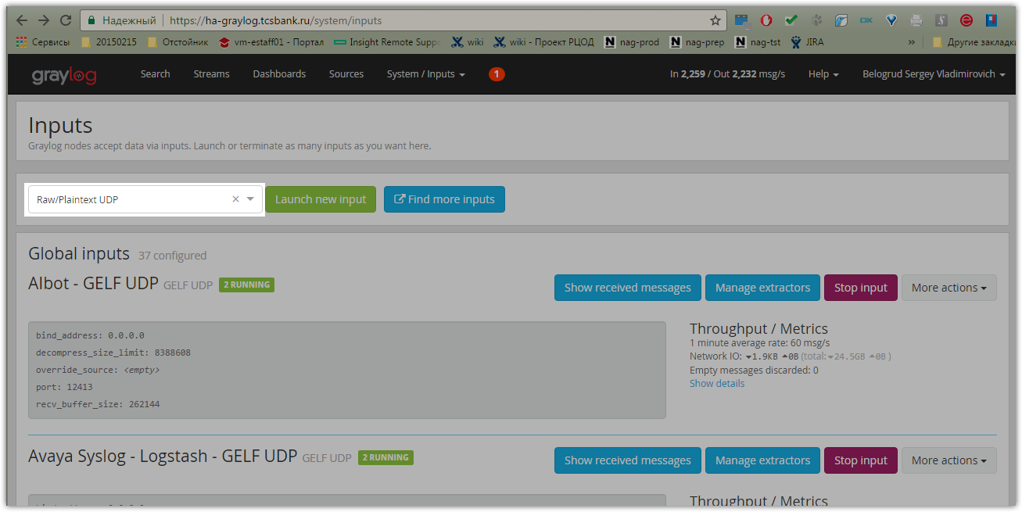

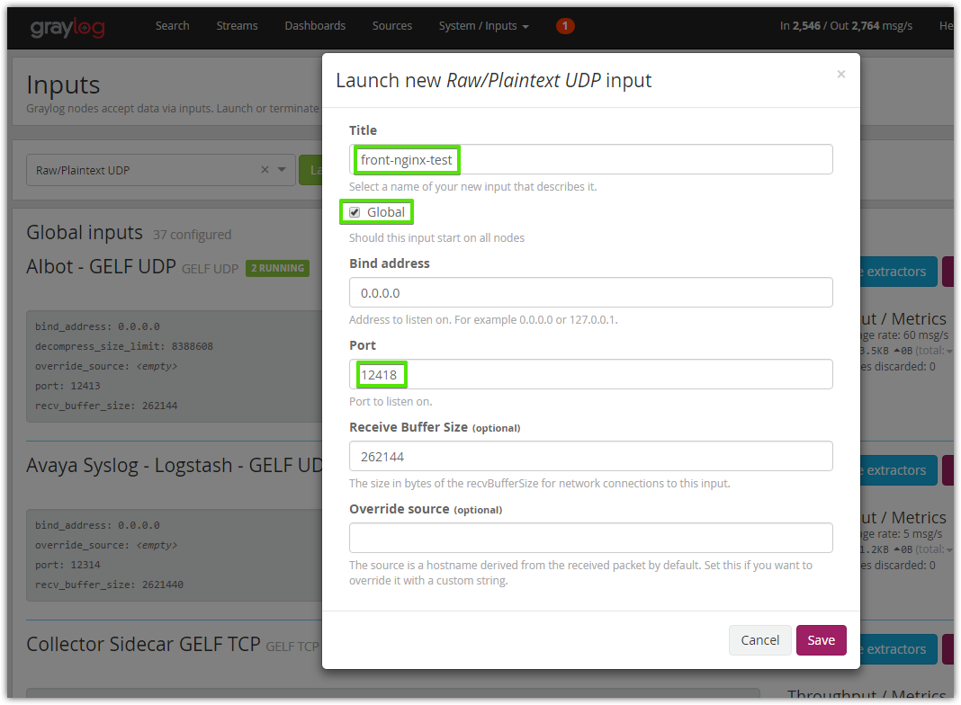

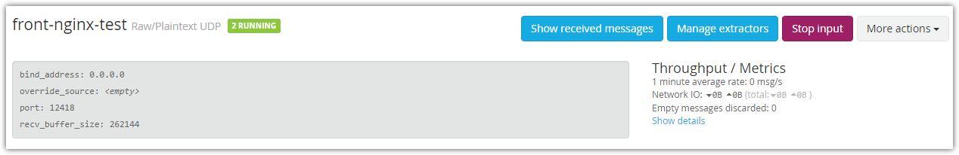

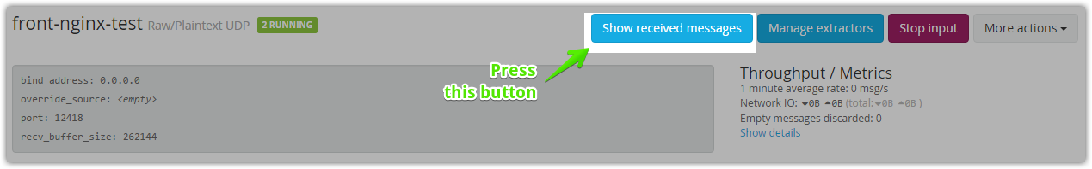
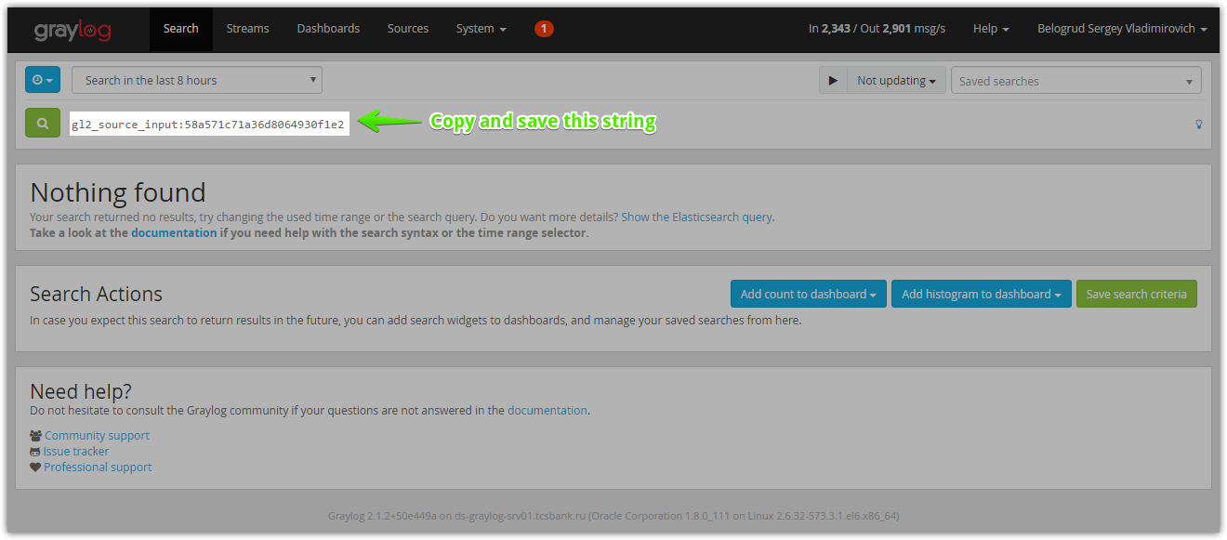

# “Create Stream”.
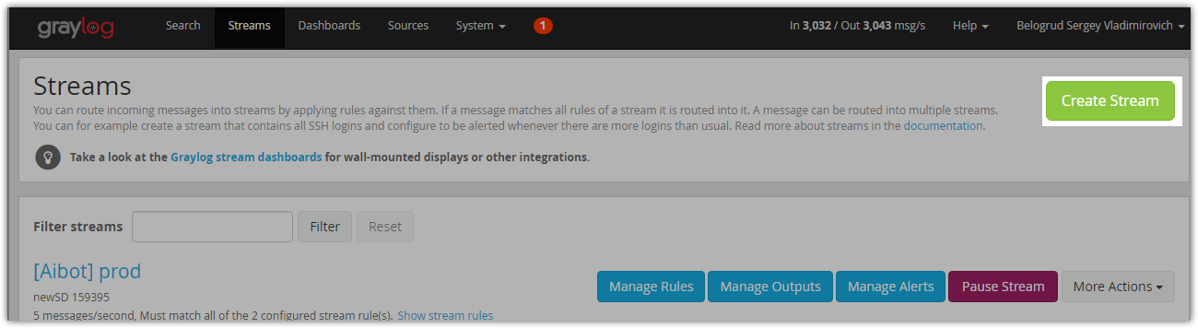

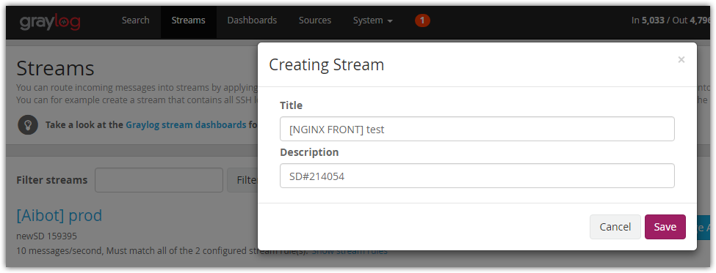

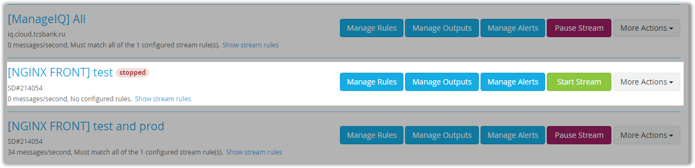

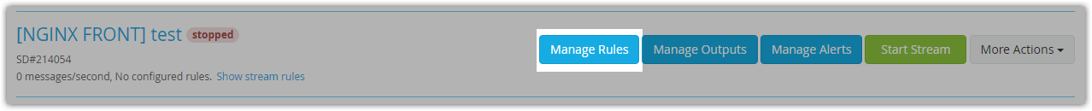

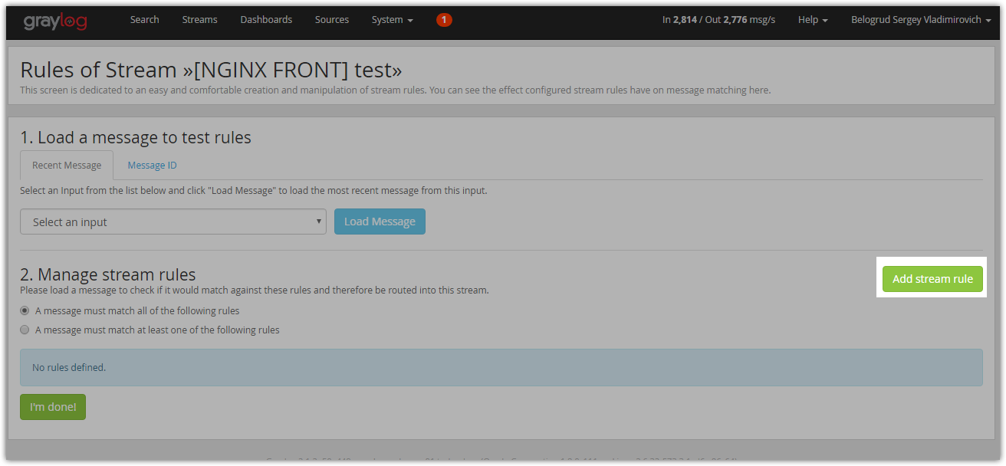

# Insert previously saved value here.
# gl2_source_input:58a571c71a36d8064930f1e2
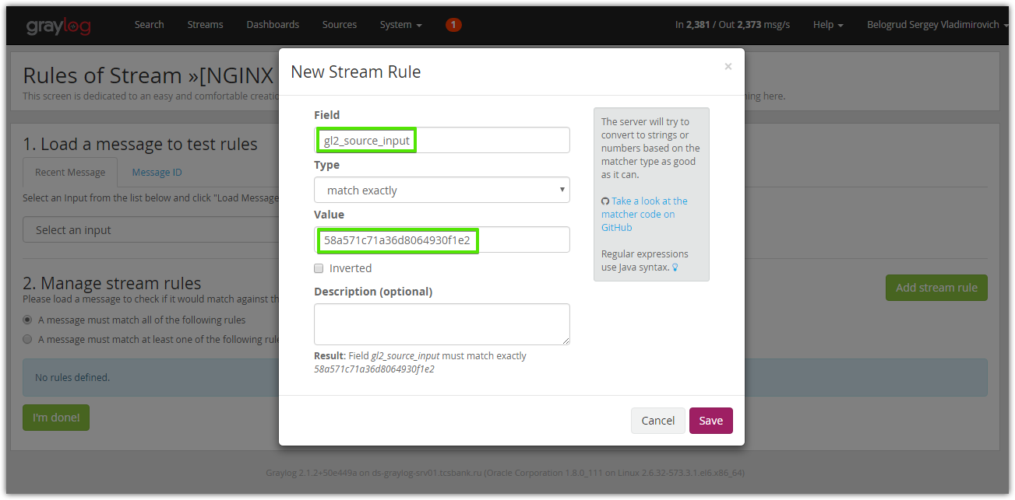

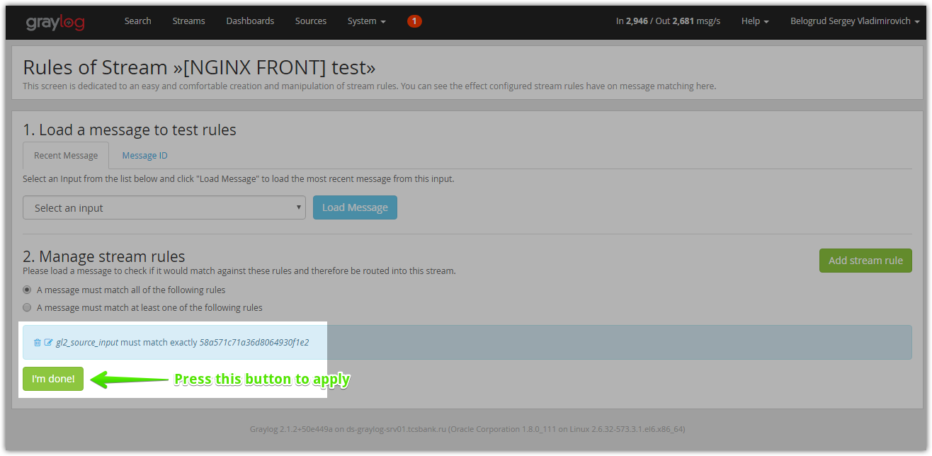

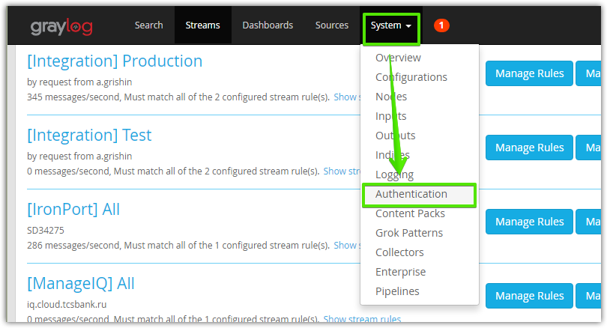

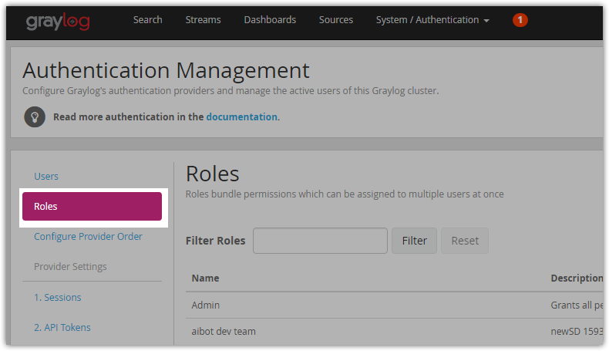

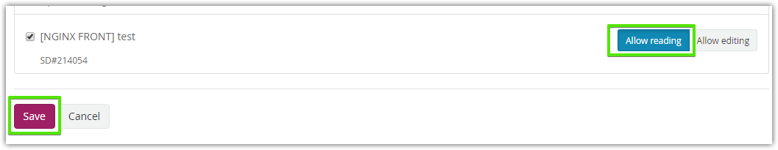

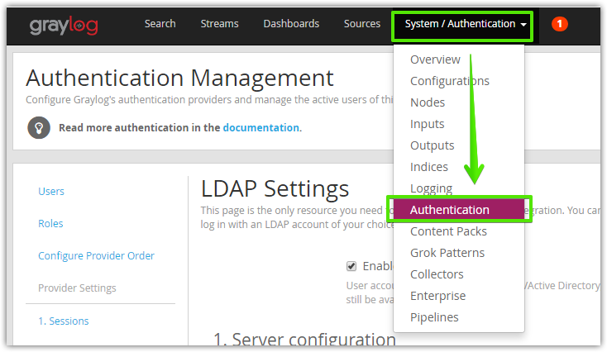

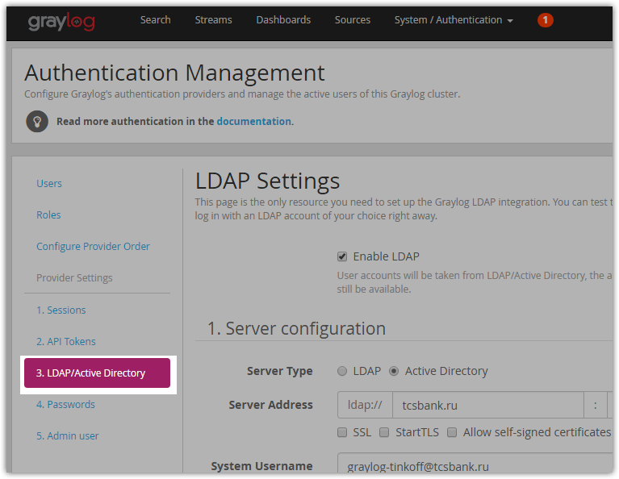

# To add active directory group to use it by graylog need to use follow field.
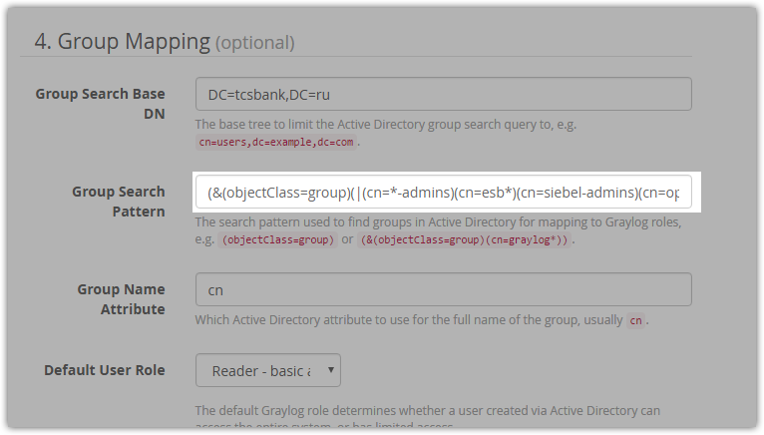

# After that it’s need to make “LDAP Group Mapping”.
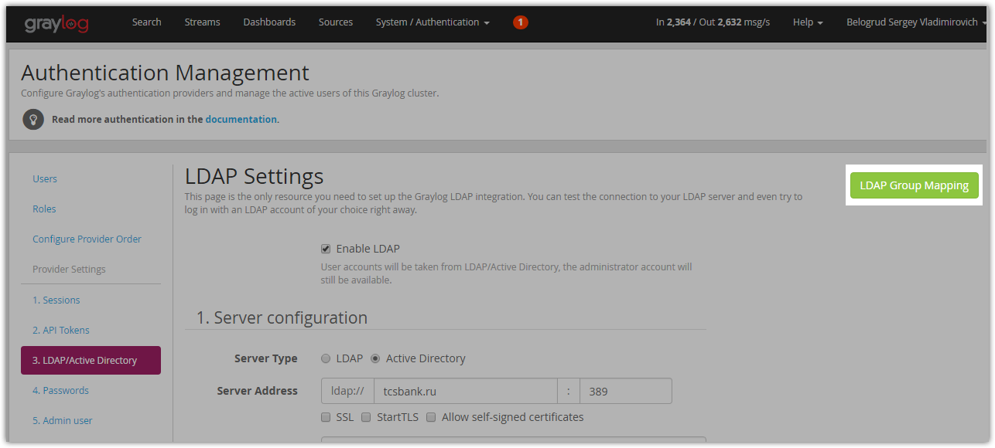

# Here it’s need to be choose appropriate “Roles”.
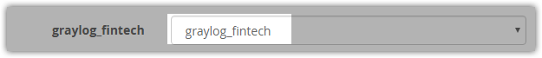

# The “Roles” created previously here.
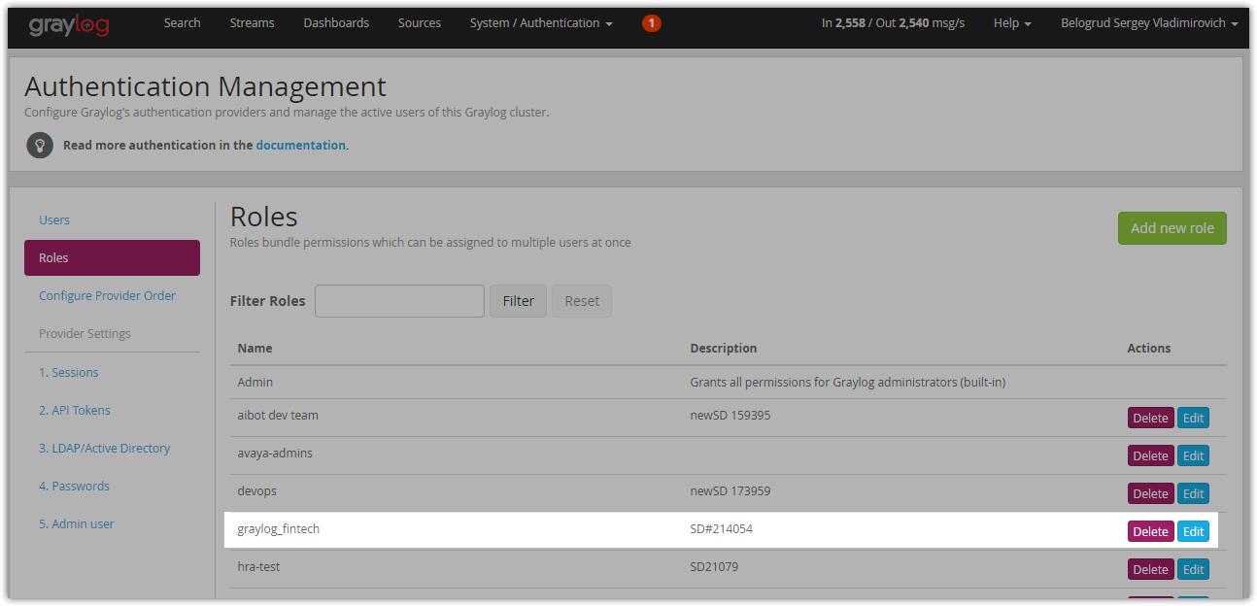

#
# 20180424
# Here is a way to create GELF TCP Input.

# Yellow fields should be cleaned.
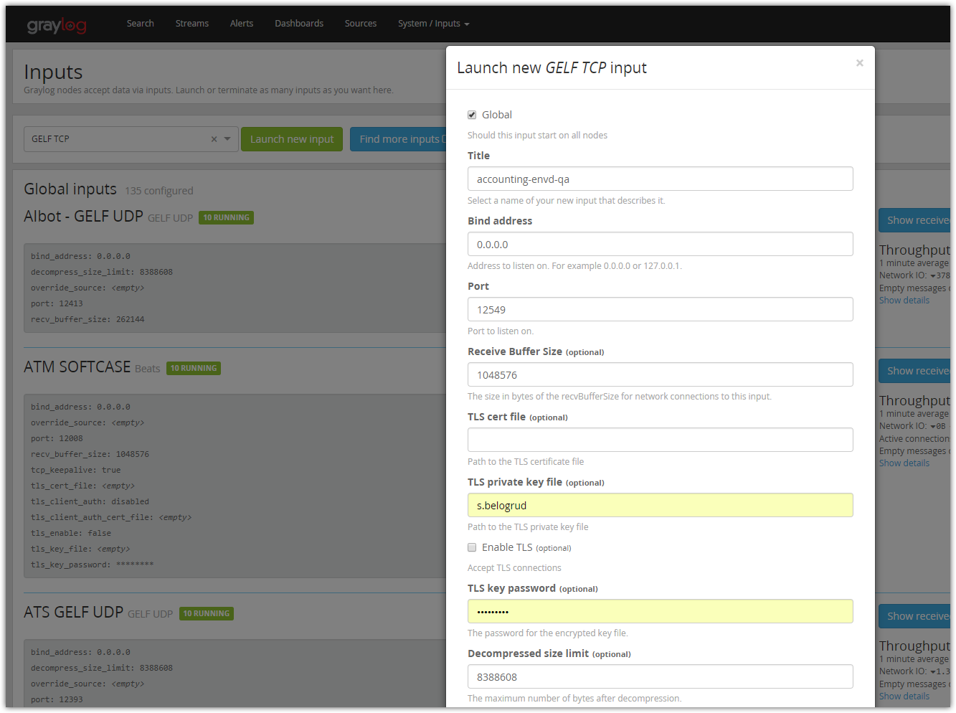

#
# I’ve cleared fields about tls_key_file and tls_key_password.
# I’ve made it as similar existed inputs.
#
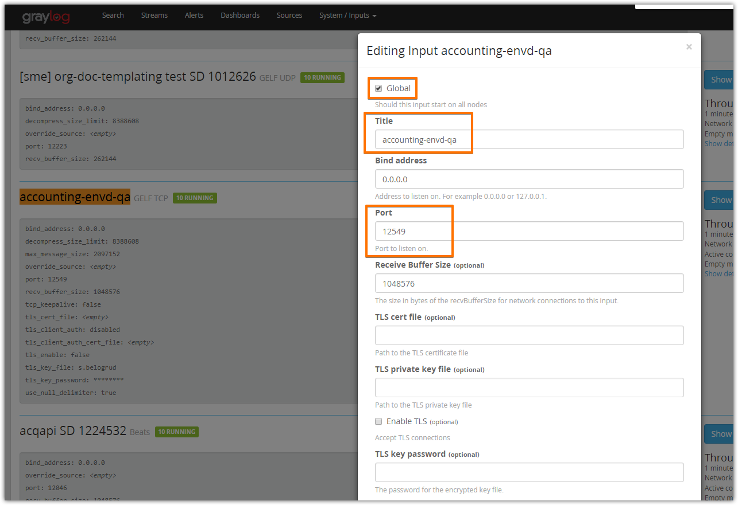
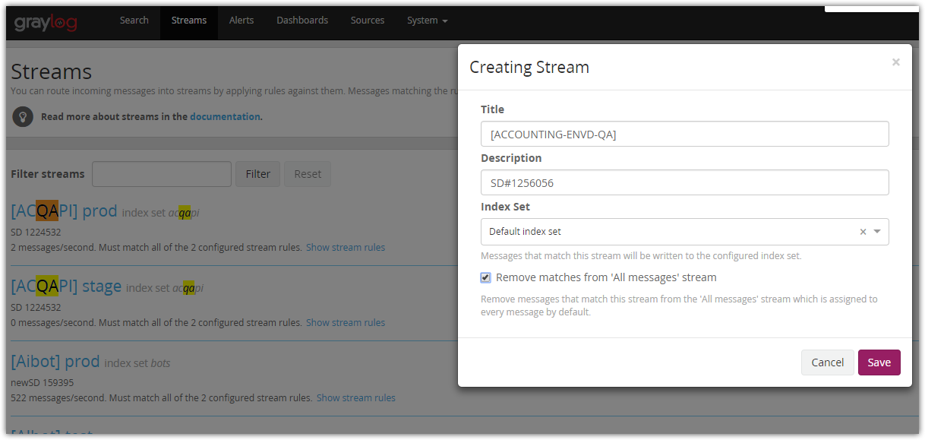
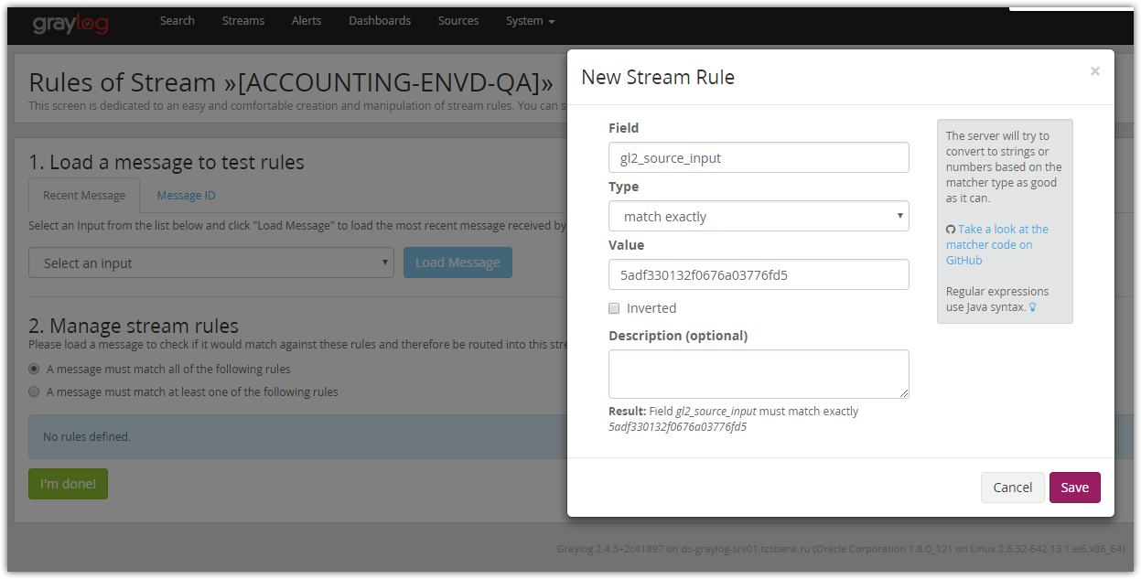

#
# At this moment I’ve made a local connection test.
#
[root@ds-graylog-lb01 ~]# telnet ha-graylog.tcsbank.ru 12549
Trying 10.216.40.170...
Connected to ha-graylog.tcsbank.ru.
Escape character is '^]'.
^]

telnet> quit
Connection closed.
[root@ds-graylog-lb01 ~]#

#
# Then I’ve made remote connection test.
#
[s.belogrud@TCS4357]# ssh bsv@ost-ibul-qa3-acct-envd-1.ibul.m1.tinkoff.cloud

root@ost-ibul-qa3-acct-envd-1:~# telnet ha-graylog.tcsbank.ru 12549
Trying 10.216.40.170...
Connected to ha-graylog.tcsbank.ru.
Escape character is '^]'.
^]

telnet> quit
Connection closed.
root@ost-ibul-qa3-acct-envd-1:~#

#
# Next I’ve made to test by send message to graylog.
#
root@ost-ibul-qa3-acct-envd-1:~# echo -e '{"version": "1.1","host":"example.org","short_message":"Short message","full_message":"Backtrace here\n\nmore stuff","level":1,"_user_id":9001,"_some_info":"foo","_some_env_var":"bar"}\0' | nc -w 1 ha-graylog.tcsbank.ru 12549
root@ost-ibul-qa3-acct-envd-1:~#
#
# Add -u parameter to nc in case we want to use UDP.

#
# Here I’ve seen, that one message was received.
#
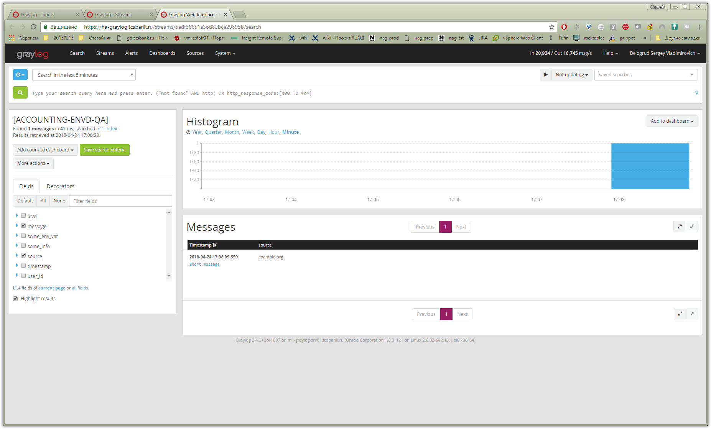

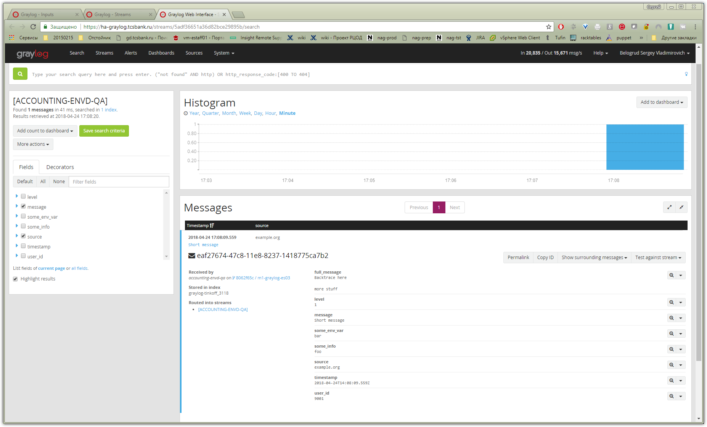

Белогруд Сергей Владимирович
Созданный Input протестирован. Тестовое сообщение получено. Скриншот во вложении к заявке.
Сегодня в 17:18
Белогруд Сергей Владимирович
Создан Input: accounting-envd-qa
Тип: GELF TCP, Host: ha-graylog.tcsbank.ru; Порт: 12549
( gl2_source_input:5adf330132f0676a03776fd5)
Создан стрим: [ACCOUNTING-ENVD-QA]
Учётной записи i.chepurin на ha-graylog предоставлены права к стриму [ACCOUNTING-ENVD-QA].
Сегодня в 17:01
Чепурин Иван Александрович
Да, именно так
Вчера в 11:15
Белогруд Сергей Владимирович
Правильно я понимаю, что вам требуется создать (в терминологии GrayLog) input в который вы будете записывать данные с двух серверов?
Вчера в 11:10

https://serverfault.com/questions/591758/send-echo-message-to-graylog2-via-gelf-tcp-12201-port

Here is a command that will work for Logstash + Gelf over UDP :

echo '{"version": "1.1","host":"example.org","short_message":"A short message that helps you identify what is going on","full_message":"Backtrace here\n\nmore stuff","level":1,"_user_id":9001,"_some_info":"foo","_some_env_var":"bar"}' | gzip | nc -u -w 1 127.0.0.1 12201

Notice that :
- a simple echo is enough, no need for -e
- the message is gziped, otherwise you'll get this error : Could not find parser for header: [123, 34] in Logstash logs
- netcat is sending over UDP

